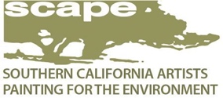 FOR IMMEDIATE RELEASE
https://scape.wildapricot.org
805/683-1878 310/869-7072
CLIMATE + ART = CHANGE
A Live and online show to benefit the CEC and the SIERRA CLUB (Los Padres Chapter)

When: Saturday, October 23, 1-8pm, Reception: from 5-8pm (wine, music, bites, awards)
Sunday, October 24, 10am-5pm
Where: Community Arts Workshop (CAW), 631 Garden St., downtown SB, 93101
Live: Free & Open to the Public (with current Health guidelines)
Online: Viewing and Sales October 16 through October 22nd, 2021
CEC Outreach and Events Coordinator Iris Kelly: (805)963-0583x209

Southern California Artists Painting for the Environment (SCAPE) along with the Climate Reality Project (CRP) are presenting this two-day special Art Exhibit & Sale, plus Educational Events to benefit the award-winning Community Environmental Council (CEC) and the dynamic Los Padres Chapter of Sierra Club. All participating organizations are focused on climate actions and solutions that are needed NOW.

Over 130 artworks reflecting our climate themes will be featured in the large ASSEMBLY room of the Community Arts Workshop, with artists on site throughout the show. Jurist and established local artist Holli Harmon will be hosting her art, along with over 75 known Scape artists.
40% of proceeds from art sales will benefit the CEC and SIERA CLUB.
Information tables, panel discussions, and screenings of short films will be hosted by the Climate Realty Project, CEC and Sierra Club in the SHED room where action items will be provided on how we can further address the climate crisis.
EXPLORE ECOLOGY will host a children’s activities tent on Saturday, October 23rd. Kids of all ages (with parental supervisor) are welcome.
FAQs
Saturday’s line-up in the CAW’s SHED begins with UCSB Professor Roland Geyer providing a climate change overview from a global perspective. Saturday’s afternoon schedule also includes a panel discussion on wildfires, moderated by Montecito Fire Chief Kevin Taylor, and features retired SB Fire Chief Pat McElroy, Wildlands specialist Nic Elmquist and UCSB Professor Leila Carvalho.
Sunday’s Programming includes a Sustainability Panel with SB Climate and Energy manager Alelia Parenteau moderating along with SB County’s Garrett Wong and Carpinteria’s Erin Maker.

This two-day event will feature a RECEPTION from 5-8 on Saturday, October 23rd, with music, wine, snacks, beginning with the award winners and recognitions from participating organizations enhanced by John Palminteri as our Reception Emcee.

For art information contact Exhibits Chair Natalie Wilson: 805/687-7123
For educational programming contact Dorene White: 805/886-7479
For CEC sales & information contact Iris Kelly: 805/963-0583x209 ikelly@cecmail.org

Artist HOLLI HARMON is SCAPE’s Juror for the CLIMATE CHANGE Benefit Show
Holli grew up in the small town of Redlands in Southern California, where her upbringing was equally eccentric and mainstream, similar to her surroundings. Her adult years took her from UC Santa Barbara for a Bachelors degree and then to San Diego State for graduate school. She and her husband migrated back to Santa Barbara to raise their children and have remained here for the last 30+ years. She has shown extensively in group and solo exhibitions including the Wildling Museum of Art and Nature in Solvang, Sullivan Goss – An American Gallery in Santa Barbara, the celebrated collective “Rose Compass: Paintings of “the Santa Barbara Watershed” at the Westmont Ridley Tree museum of Art in Montecito as well as the Wildling’s “The River’s Journey”, “The Lone Woman” Portrait Unveiling at the Santa Barbara Museum of Natural History, “Making Waves” solo show at Porch, Carpinteria, and Solo Exhibition “Revelations” at the Elverhoj Museum of History and Art, Solvang, CA. See her website for affiliated art associations and commendations. www.holliharmon.com See her featured work and statement at the Show!

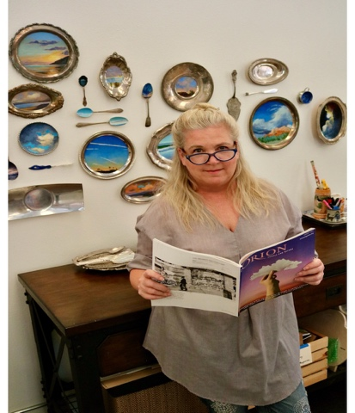

About SCAPE
SCAPE was founded in 2002 and has grown to over 200 members, a diverse group including nationally known and local artists, students, patrons, and gallery owners. Membership is open year-round to everyone who wants to participate. SCAPE’s goals are to have exhibitions to help raise money to protect open spaces, to increase public awareness of environmental and conservation issues, to promote camaraderie and provide education for artists. They mount 2-3 juried exhibits every year to provide a platform to show their artwork.
www.scape.wildapricot.org
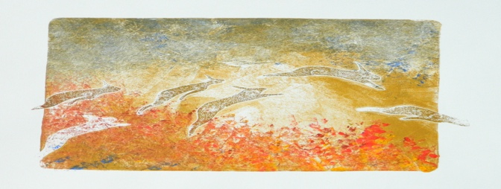
“Nowhere to Run” 8x10” monotype by Anthony Galvan
“the wildfires in Australia coupled with our local wildfires inspired me to work on a few pieces with that theme. Having seen herds in the Serengeti running from wildfires I created this monotype. As we have seen last year, entire communities were on the run as well.” (Anthony Galvan)

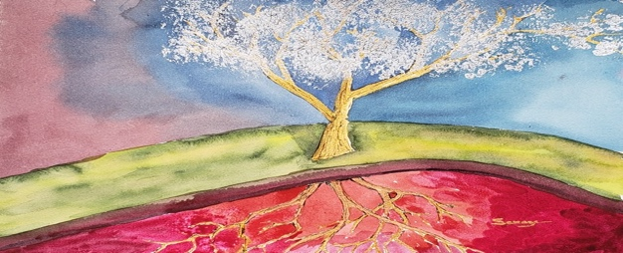
“Heavy Metals” 11x14” watercolor with iridescent Gold & Silver by Lee Savage
“This painting is a watercolor with iridescent Gold and silver. The Earth’s crust is depicted, with the Earth’s core and sky. The tree is composed of gold and silver as a result of pollution and Climate Change rather than natural.” (Lee Savage)
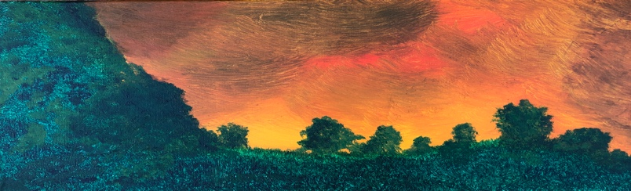
“Restoration” 24x12 Acrylics on stretched canvas by Ron Ehmsen
“The scene depicted in the painting is of a forest fire near the Valles Caldera National Preserve in New Mexico. It is a representation of the increasing frequency and number of fires caused by climate change.
The title stems from the aftermath ofsuch devastating fires, a time when the forest hopefully regenerates itself.” (Ron Ehmsen)

